**PRACTICAL NO: 9**

# 1.LOGIN

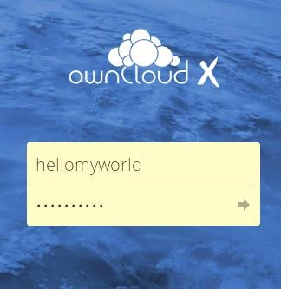

# 2.ADD USER

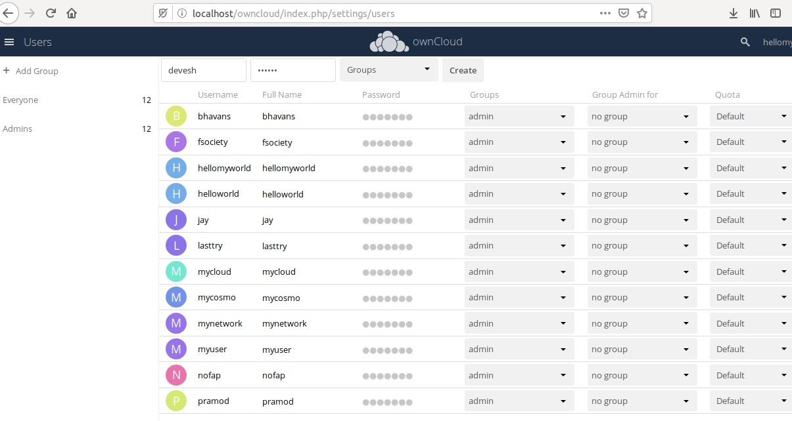

# 3.CHANGE PASSWORD

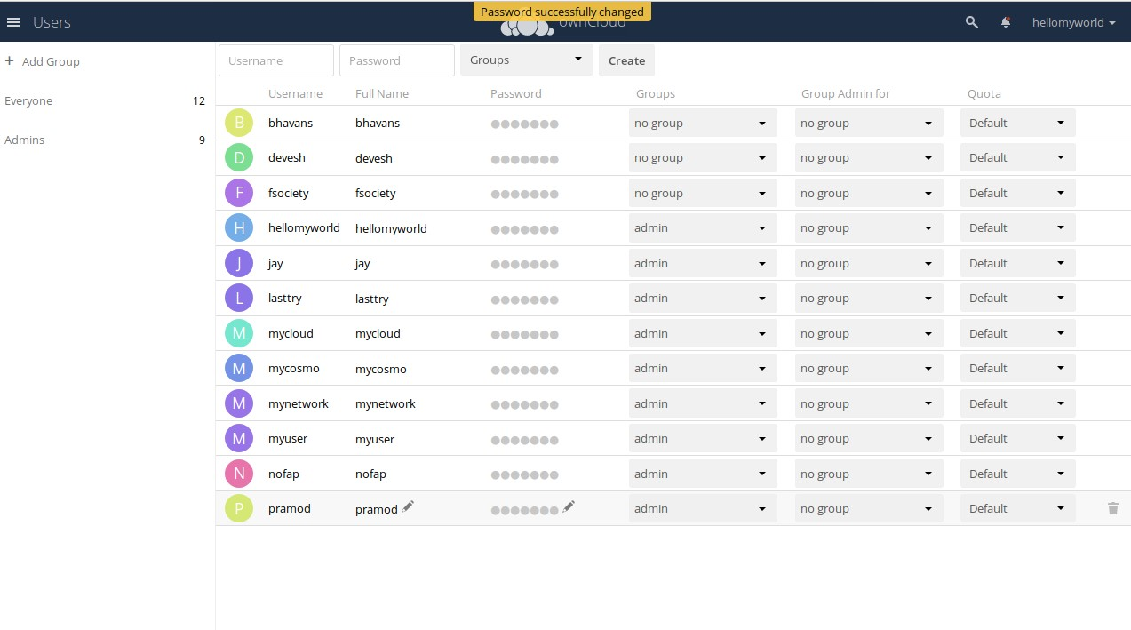

# 4.DELETE

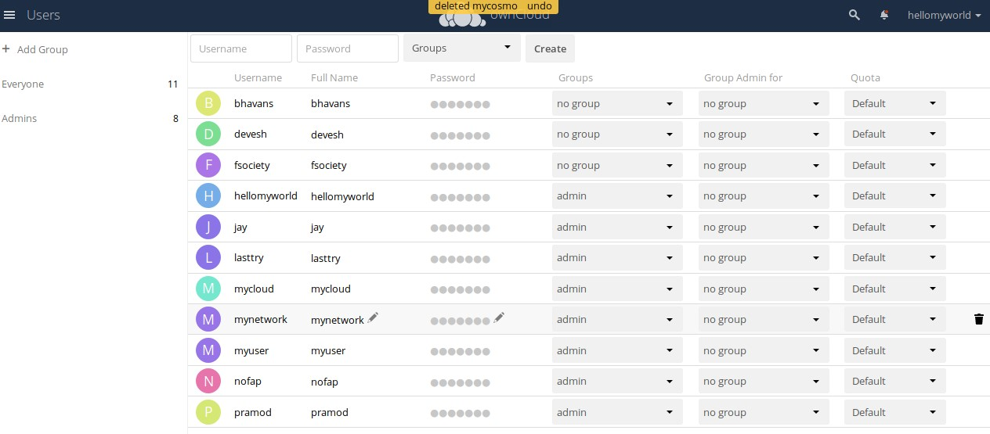

# 5.CREATE GROUP

click on ADD Group

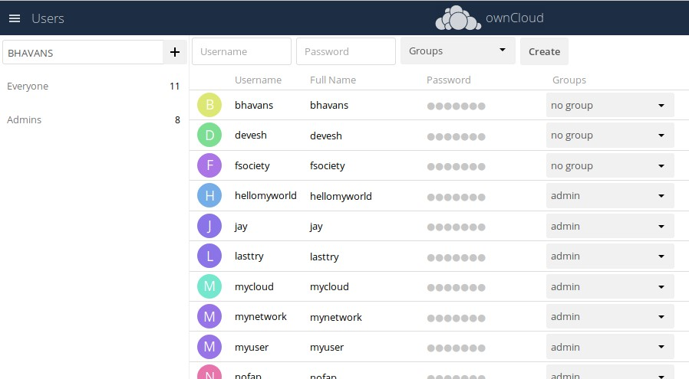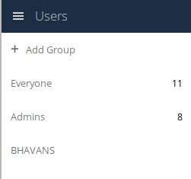

# 6.GROUP ADMIN

